Set ups & Payoffs
Your YouTube script has three objectives:
- Engage viewers, keeping them curious and invested.
- Simplify complex information so anyone can understand it.
- Build credibility so viewers trust and want to return to you as their go-to source.
But how do you keep them engaged?
The secret lies in mastering setups and payoffs to create and release tension

Tension and Release
A great script is a game of building tension and releasing it repeatedly.
- Tension grabs attention
- Release satisfies curiosity.
Think of TV cliffhangers: they build suspense and leave you desperate for the next episode.
Similarly, YouTube scripts must constantly build and release tension to keep viewers glued.
Even if your video is about something mundane, like reviewing brussels sprouts, your script’s structure must create curiosity and satisfaction.
This cycle of tension (setup) and release (payoff) is the backbone of any engaging video and you create this using set ups and payoffs.

What Are Setups and Payoffs?

Setups
A setup introduces an idea, question, or situation designed to spark curiosity. Like the opening of a joke, it hooks the audience:
- Example: “Why don’t skeletons fight each other?”

Payoffs
A payoff delivers the answer or resolution to the setup, satisfying the viewer’s curiosity:
- Example: “Because they don’t have the guts!”
In scripts, setups make viewers want to know more, while payoffs provide the information or resolution they seek. However, paying off too early can kill curiosity and lose viewers.

Crafting Effective Setups and Payoffs
- Start Strong with the Intro
  - Your intro is the first setup, promising viewers what they’ll learn.
  - Example: “In this video, you’ll discover why your team isn’t listening and how to fix it.”
- Use Questions to Hook Viewers
  - Questions are powerful setups that make viewers crave answers.
  - Example: “What’s the one mistake destroying your productivity?”
- Tease Future Content
  - Teases act as setups for later payoffs.
  - Example: “By the end of this video, you’ll know how to bake the perfect cake.”
- Avoid Early Payoffs
  - Don’t reveal the answer too soon, or viewers will lose interest.
  - Example of a bad script:
    - Setup: “Why doesn’t your team listen?”
    - Early Payoff: “Because you’re not writing instructions.”
    - Solution: Unpack the problem first, then provide the solution.
*The way I will teach you how to structure you’ll avoid early payoffs (See structure guide for more info)
- Structure Like a Rollercoaster
  - Alternate between setups and payoffs to keep curiosity high:
    - Setup: “Why don’t cakes rise properly?”
    - Payoff: “Because you’re not measuring ingredients accurately.”
    - Next Setup: “But how do you measure them perfectly?”

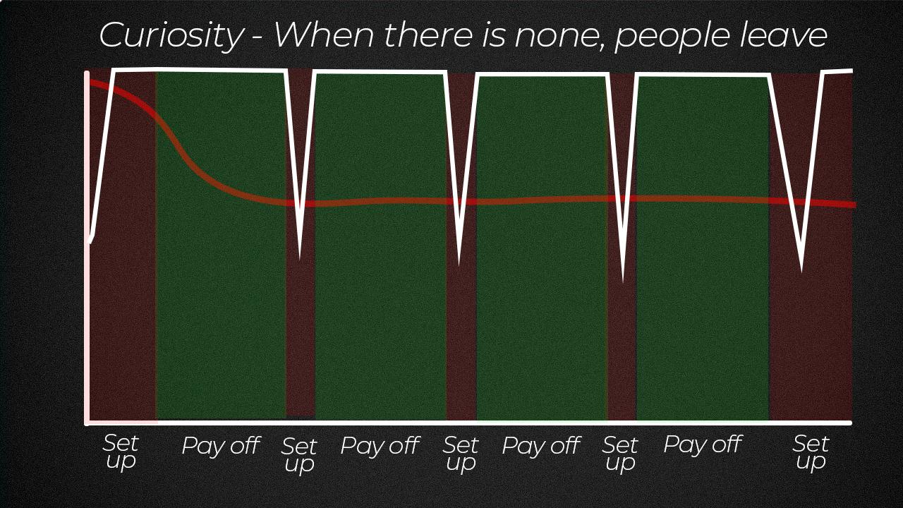

Types of Setups
- Tease a Reveal
  - Example: “By the end of this video, you’ll know the secret to perfect pancakes.”
- Ask a Question
  - Example: “But how do you make jam that’s the perfect blend of gooseberry and gin?”
- Introduce a Problem
  - Example: “I’m testing three productivity methods to see which works best.”
- List What’s Coming
  - Example: “Next, I’ll show you how to pick the best gooseberries for your jam.”
  - Add why it matters: “So your cake doesn’t taste like dust.”

Where to Use Setups and Payoffs
- Intro
  - Set up what the video will cover in a way that sparks curiosity.
- Throughout the Script
  - After every payoff, introduce a new setup to keep the viewer engaged.
  - Example: “Which brings us to the fifth method…”
- End Screen
  - Use the end screen to set up the next video.
  - Example: “Want to learn the ultimate tip for raising credibility? Check out this video.”

Common Mistakes to Avoid
- Paying Off Too Early
  - Early payoffs kill curiosity. Instead, unpack the setup before revealing the answer.
- Forgetting Payoffs
  - Failing to resolve a setup frustrates viewers and damages credibility.
  - Solution: Highlight setups in your script to ensure you pay them off.
- Clickbait Without Payoff
  - Don’t promise something in your title or thumbnail that the video doesn’t deliver.

Mastering the Art of Setups and Payoffs
Practice makes perfect. Over time, as you analyze your retention data, you’ll learn which setups resonate with your audience and refine your approach.
- Track Your Setups: Highlight them in your script for easy reference.
- Experiment: Test different setups and payoffs to see what works best.
- Analyze Retention: Use analytics to identify where viewers drop off and adjust accordingly.

Final Thoughts
Your video’s job is to create curiosity and then satisfy it while continuously keeping viewers hooked. By mastering setups and payoffs, you’ll ensure your audience stays engaged, learns from your content, and trusts you as a credible source.
Now that you understand setups and payoffs, let’s move on to structuring your video for maximum impact!

